
THE EFFECTS OF COVID-19 PANDEMIC IN TURKEY
Ayça Yaren Arslan, Elif Beyza Akyıldız, Fatoş Aydın, Pelin Topaz
Prof. Dr. Özlem İlk Dağ, Res. Asst. Ozancan Özdemir
December 22, 2021

- ABSTRACT
One of the most critical issues of today is coronavirus that has been seen in more than two hundred countries worldwide. In this study, we try to develop a method that can detect and predict the emergence of new cases of COVID-19 at an early stage by using the popularity of Google searches related to smell loss and taste loss. Additionally, we aim to investigate the relationship between the number of weekly confirmed COVID-19 cases and weekly Google Searches including the dates between 2020-03-15 and 2021-12-05. This project comprises several stages starting from the data manipulation to analyze and predict the number of coronavirus cases by considering the number of Google Searches. The findings obtained in Turkey have demonstrated that the trend followed by Google trends is not similar to the trend followed by weekly coronavirus cases. We observed correlations between weekly Google searches related to loss of smell and taste, increases of weekly COVID-19 cases.

- EXPERIMENTAL PROCEDURE
We are using two different methods to conduct this project. The first one is to construct a generalized linear model with longitudinal data analyses. In this way, we can estimate the number of cases by calculating the weekly number of coronavirus cases in Turkey. The second method is to construct the time series model and machine learning techniques. Thanks to the time series model, we are able to forecast the number of cases by using the previous number of coronavirus cases and the number of google searches about loss of smell and taste as our independent variables. In this way, we want to develop an early warning system. Moreover, we are planning to benefit from the temperature and the number of people in a city for independent variables. At the end of these two methods, we are going to make a decision about which one is more efficient. Until now, we analyzed our dataset with time series analyses. In order to retrieve the data, we benefited from Google Trends. We defined ten concepts that individuals may perform a Google search for when experiencing anosmia or ageusia: “koku alamıyorum”, “tat alamıyorum”, “koku kaybı”, “tat
kaybı”, “tat ve koku kaybı”, “korona tat kaybı”, “korona koku kaybı”, “covid koku kaybı”, “covid tat

kaybı”, “covid koku ve tat kaybı” in Turkish. All these ten concepts are gathered into one unique concept as a variable because our primary purpose is to apply all the statistical analysis and machine learning algorithms between the number of weekly cases and the total number of weekly Google searches.
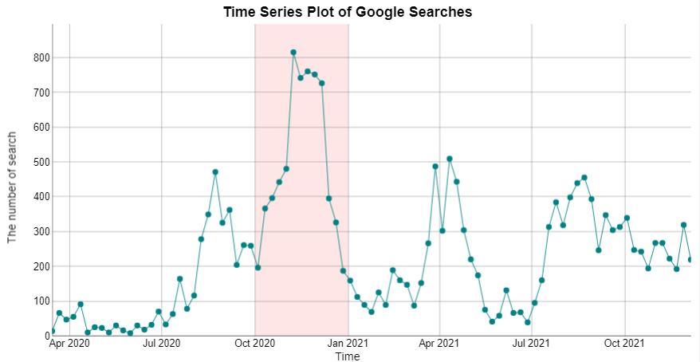

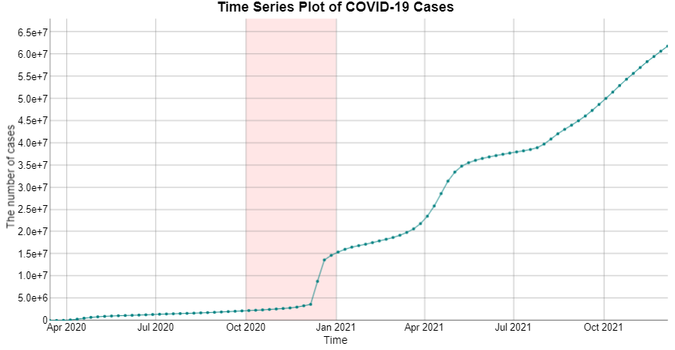

Figure 1. Time Series Plots

- MOTIVATION
Our motivation is to determine which side effects of coronavirus predict best the weekly number of COVID-19 cases. We are taking advantage of Google searches about side effects of coronavirus, such as loss of smell and taste in terms of cities in Turkey. We thought that the graph of the weekly number of COVID-19 cases versus time and the number of Google searches about loss of smell and taste versus time might show the same pattern. For this reason, we think the loss of sense of smell and taste are one of the important effects of COVID-19 pandemic. The main goal of this research is to investigate the relationship between the weekly number of COVID-19 cases and weekly Google searches about loss of smell and taste in Turkey. In addition, we wanted to forecast the weekly number of COVID-19 cases by using the number of weekly Google searches about loss of smell and taste.
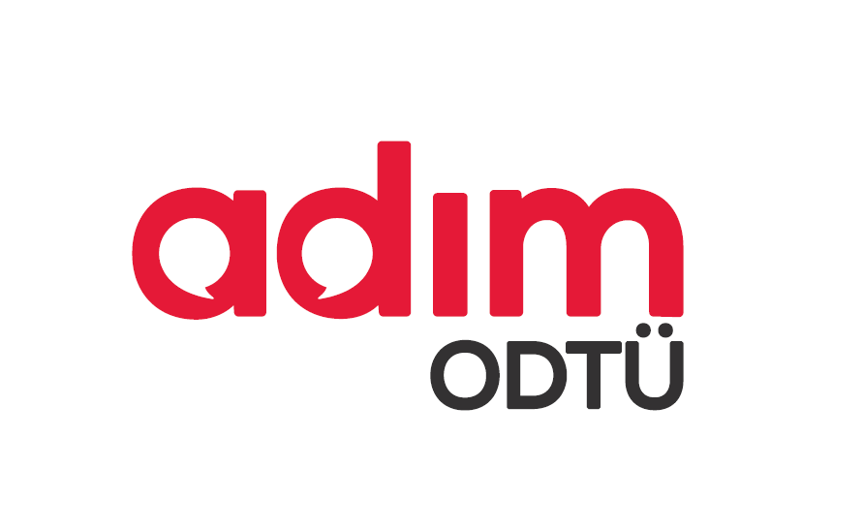
https://trends.google.com/trends/?geo=TR

- RESULTS AND DISCUSSION
Due to the recent increase in widespread usage of mobile internet and the use of Google on the biggest platforms as the primary search engine, this data has become more reliable when compared to previous years. According to Figure 1, it can be seen that the number of Google Searches about loss of smell and taste versus time and the number of weekly COVID-19 cases versus time seem in different patterns. On the other hand, we realized that the number of cases and searches increased sharply between October 2020 and January 2021 for these two time series graphs. Therefore, we tested the correlation between the number of Google Trend hits and the number of weekly COVID-19 cases in Turkey. Based on the correlation result, there is a positive linear relation between these two variables, and it was statistically significant.

- CONCLUSION
In this study, data analysis methods were performed to reveal the relationship between the words searched in Google Trends and the number of coronavirus cases and search word patterns depending on the determined search terms. We have demonstrated that there is clear association between Google Trends search terms and Covid-19 cases on a national basis. November is the month with the highest number of hits for related search terms on Google Trends. As a future work, we could use this dataset to study if search trends can provide an earlier and more accurate indication of the reemergence of the virus in different parts of the country. This method may enable public health officials and health professionals to better respond to seasonal epidemics. If a region experiences an early, sharp increase in COVID-19 like illness, it may be possible to focus additional resources on that region to identify the etiology of the outbreak, providing extra vaccine capacity or raising local media awareness as necessary. More examples will be illustrated in the final report, including all the regions of Turkey.

- REFERENCES
https://trends.google.com/trends/?geo=TR
TURCOVID19 | Açık Veri | TURCOVID19. (2020, May 4).
https://turcovid19.com/acikveri/
Google Trends. (n.d.). Google Trends. Retrieved December 16, 2021, from

